| 9. ReactJS-HOL |
| --- |

* ES6, or ECMAScript 2015, introduced several new features to JavaScript that made the language more powerful and easier to write. Some of the key features of ES6 include block-scoped variables using let and const, arrow functions for shorter function syntax, classes and inheritance for object-oriented programming, template literals for easier string formatting, destructuring assignments, spread and rest operators, modules for better code organization, promises for handling asynchronous operations, and new data structures like Map and Set.

* The let keyword allows you to declare variables that are limited in scope to the block in which they are defined. Unlike var, which is function-scoped, let helps avoid issues caused by variable hoisting and accidental re-declarations. The const keyword also declares block-scoped variables, but they must be initialized at the time of declaration and cannot be reassigned. However, if a const variable is an object or array, you can still modify its properties or elements.

* The main difference between var and let is their scope. var is function-scoped and allows re-declaration, while let is block-scoped and does not allow re-declaration in the same scope. Also, var variables are hoisted and initialized with undefined, while let variables are hoisted but not initialized, leading to a ReferenceError if accessed before declaration.

* ES6 classes provide a clearer and more concise way to create objects and deal with inheritance. A class is defined using the class keyword, and it can contain a constructor and methods. Classes can also extend other classes using the extends keyword, and the super() method is used to call the constructor of the parent class. This makes it easier to create reusable and maintainable code.

* Arrow functions are a shorter way to write functions in JavaScript. They are defined using the => syntax and do not have their own this context, making them useful for callbacks and functions inside objects. Arrow functions are more concise and help reduce boilerplate code.

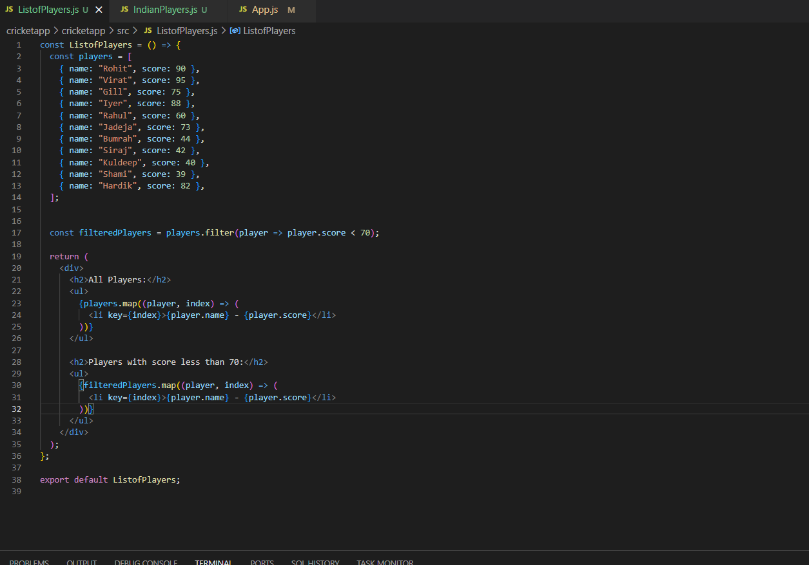

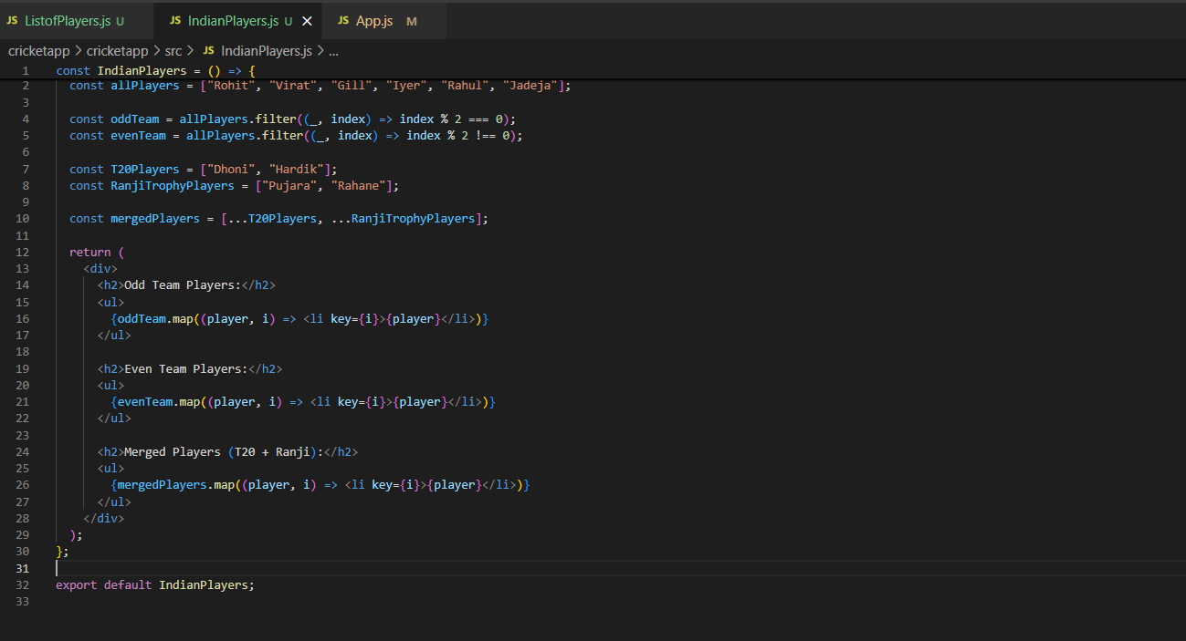

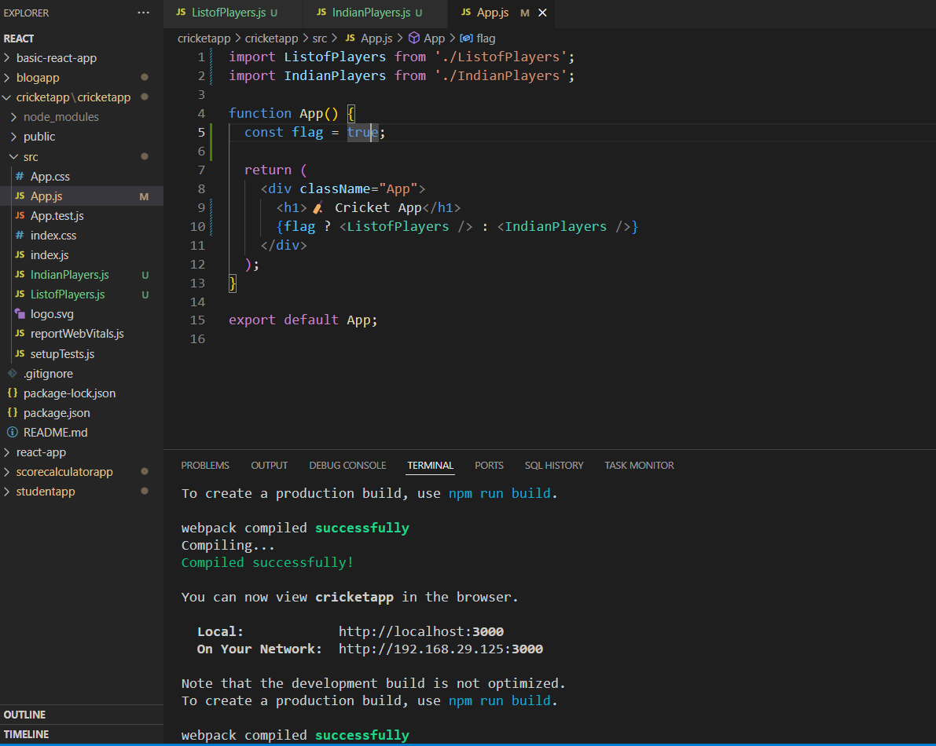

* ES6 also introduced two new data structures: Set and Map. A Set is a collection of unique values, meaning it cannot contain duplicates. A Map is a collection of key-value pairs where keys can be of any type, including objects and functions. Both Set and Map are iterable and provide methods to add, delete, and access elements efficiently.

**Output**

